

1

Cricket Player Performance Tracking
Application : CRICKSTATS

K.M.G

COLLEGE

OF

ARTS

&

SCIENCE

DEPARTMENT

OF

COMPUTER

SCIENCE

A project Report

Submitted By

DINESH M

-

(31523U18020

)

ARUNACHAM S

-
(31523U18008)

dineshteam620.e02940723300@agentforce.com.

-

(31523U18029)

GOWTHAM S

-
(31523U18047)
ARAVIND B A - (31523U18007)

MADHAN KUMAR R
Project Development Phase:
Milestone 1 | Salesforce account
Milestone 2 | object
Milestone 3 | tab
Milestone 4 | The Lightning App
Milestone 5 | Fields & Relationships
Milestone 6 | Roll-up Summary
Milestone 7 | flows

Product Backlog, Sprint Schedule, and Estimation :
Sprint | Functional  Requirement  (Epic) | User  Story  Number | User Story / Task | Story Points | Priority | Team  Member s
Sprint-1 | Developer Setup | USN-1 | As an admin, I want to create a Salesforce developer account so that I can configure and deploy the CRICKSTATS system. | 1 | High | ARISH R
Sprint-1 | Data Modeling | USN-2 | As an admin, I want to create Player and Match Performance objects so that player and match data can be stored systematically. | 3 | High | DHANUSH R
Sprint-2 | Navigation | USN-3 | As a user, I want separate tabs for each object so that I can easily navigate and manage records within the application. | 3 | High | MADHAN G
Sprint-2 | UI Design | USN-4 | As a coach, I want a dedicated Lightning App so that all performance tracking features are accessible from one dashboard. | 3 | High | LOKESH K
Sprint-2 | Data Structure | USN-5 | As an admin, I want to create player and match fields so that complete performance details can be captured accurately. | 5 | Medium | ARISH R
Sprint-2 | Data Structure | USN-6 | As a user, I want customized page layouts so that only relevant fields are displayed during data entry. | 5 | High | DHANUSH R
Sprint-2 | Automation | USN-7 | As a system, I want to validate player and match inputs so that incorrect data entries are prevented. | 3 | High | MADHAN G
Sprint-3 | Automation | USN-8 | As a system, I want automated flows to update player statistics so that performance data remains accurate. | 5 | High | ARISH R
 | 3
INTRODUCTION:
CRICKSTATS is a Salesforce-based application designed to track, manage, and analyze cricket players’ performance on a match-by-match basis. The system uses custom objects, relationships, dashboards, and automation tools to provide structured performance insights.
It enables coaches, analysts, and administrators to record player statistics, generate reports, and support strategic decision-making.

Milestone 1 - Salesforce developer account creation
• Successfully Created account in salesforce developer edition

Here is the screenshot of my developer account creation:

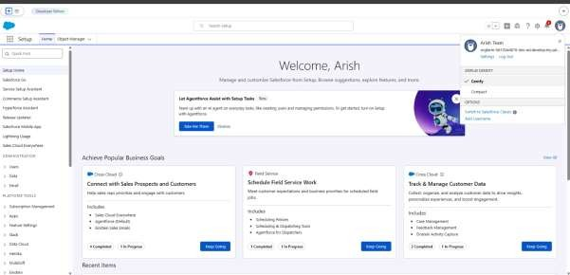

Milestone 2 - Object Creation Step to Implement:
Activity 1 : Player Object
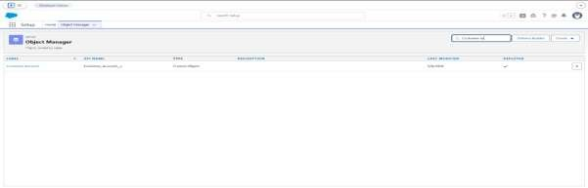
Creating new custom object named 1. First Name:
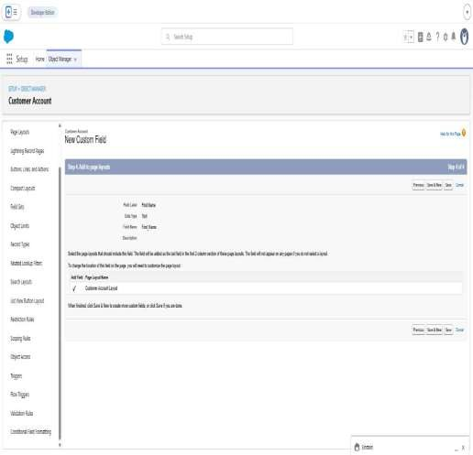

2. Last Name:
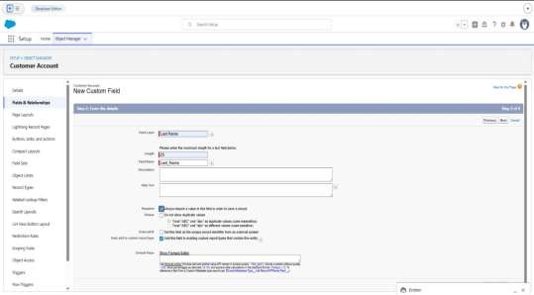

Activity 2 : Match Performance Object
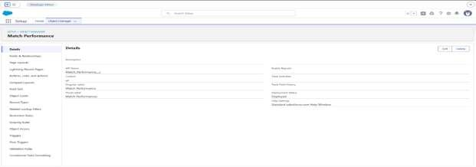

Milestone 3 – Tabs
Activity 1 : Custom tabs creation
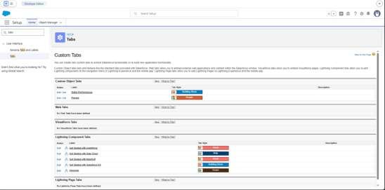
Milestone 4 - The Lightning App
Activity 1 : Create a lightning app
App Name : CRICKSTATS Developer Name : Auto Populates
Add image optional (if you want to give any image you can otherwise not mandatory) - Add Primary color Hex or leave it
to de
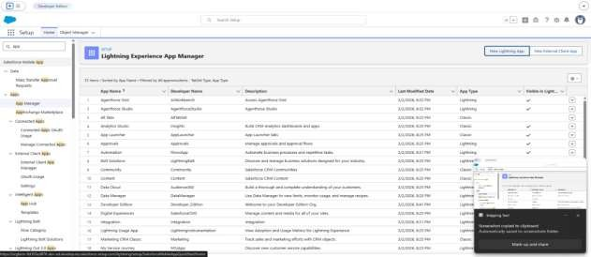
Milestone 5 : Fields & Relationships
Activity 1 : Create Custom fields for Player object
- Data Type : Text Field Label: Player Name Field Name :
Auto Populates Length : 50 Click on Next → Next → Save and new
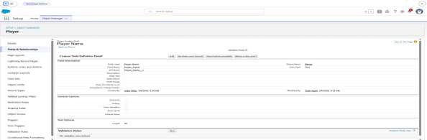
- Data Type : Rich Text Area Field Label : Profile Picture Field Name : Auto Populates Click on Next → Next → Save and new.

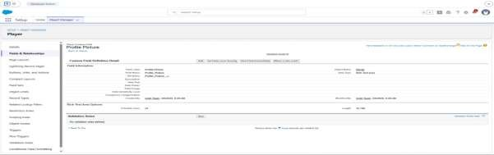

- Picklist Field Label : Role Field Name : Auto Populates Value :
Enter value
    - Batsman
    - Bowler
    - Batsman & Wicket Keeper
    - All Rounder
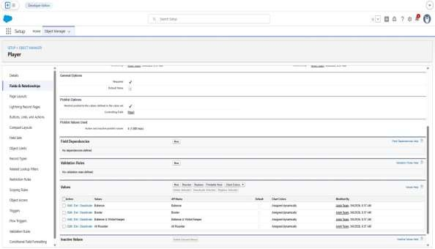

- Picklist Field Label : Bowling Style Field Name : Auto Populates Enter value:
    - Right-Arm Fast
    - Left-Arm Fast
    - Right-Arm Medium
    - Left-Arm Medium
    - Right-Arm Spin
    - Left-Arm Spin

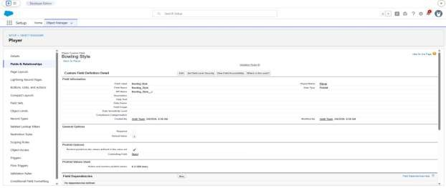
- Data Type : Picklist Field Label : Team Field Name : Auto Populates Enter value: o Chennai Super Kings (CSK) o Delhi Capitals (DC)
  - Kolkata Knight Riders (KKR) o Mumbai Indians (MI) o Punjab Kings (PBKS)
  - Rajasthan Royals (RR)
  - Royal Challengers Bangalore (RCB) o Sunrisers Hyderabad (SRH) o Gujarat Titans (GT)

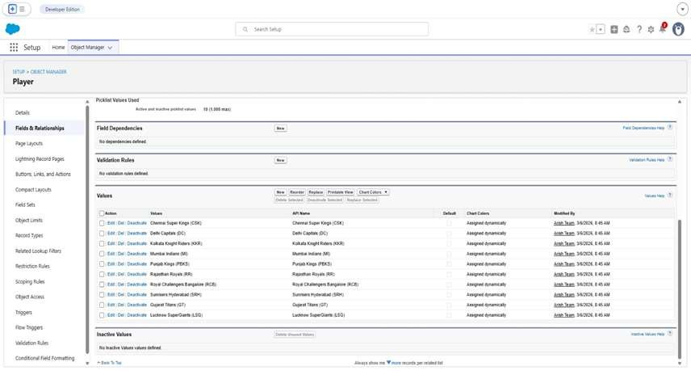

Activity 2 : Create Custom fields for Match

Performance object
- Data Type : Picklist Field Label: Match Result Field Name : Auto Populates Enter value:
  - WON
  - LOST
  - DRAW
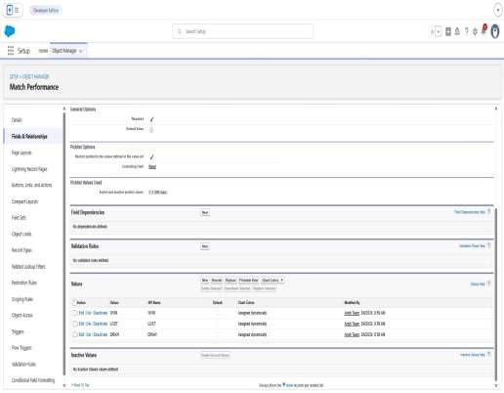

- Data Type : Number Field Label: Runs Scored Field Name : Auto Populates Click on Next → Next → Save and new.
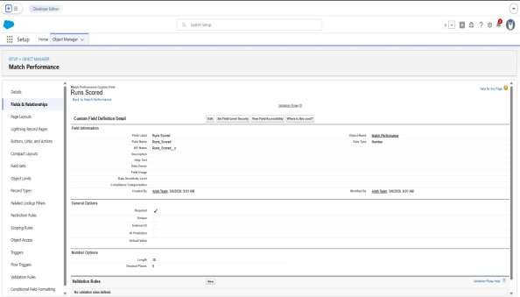

- Data Type : Number Field Label: Balls Faced Field Name : Auto Populates
Click on Next → Next → Save and new.
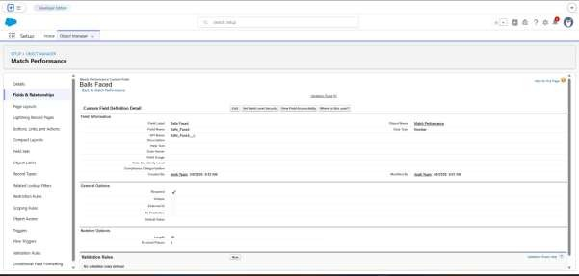

- Data Type : Number Field Label: Fours Field Name : Auto Populates
Click on Next → Next → Save and new.
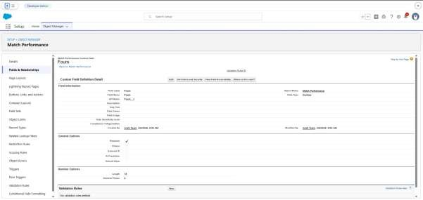

- Data Type : Number Field Label: Sixes Field Name : Auto Populates
Click on Next → Next → Save and new.
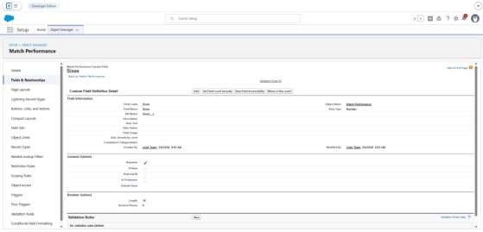
- Data Type : Number
Field Label: Overs Bowled Field Name : Auto Populates
Click on Next → Next → Save and new.
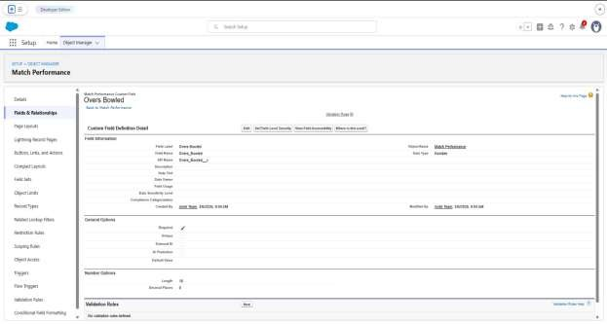

- Data Type : Number Field Label: Wickets Taken Field Name : Auto Populates
Click on Next → Next → Save and new.
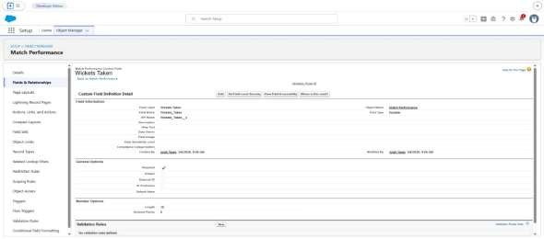
- Data Type : Number Field Label: Stumpings
Field Name : Auto Populates
Click on Next → Next → Save and new
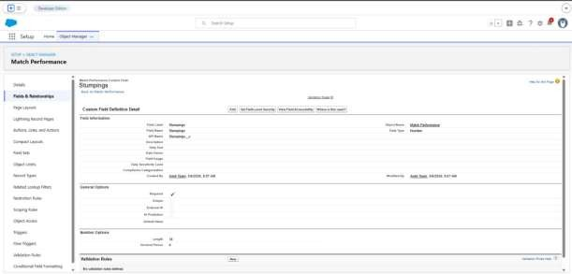

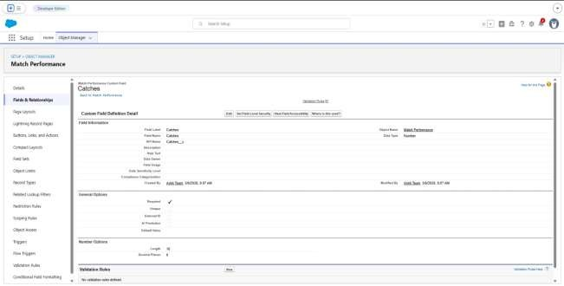
9.

Data Type : Number

Field Label: Catches

Field Name : Auto Populates

Click on Next → Next → Save and new.

10.

Data Type : Master
-

Detail Relationship

Related To : Player

Field Label : Player

Field Name : Auto Populates

Click on Next → Next → Save.

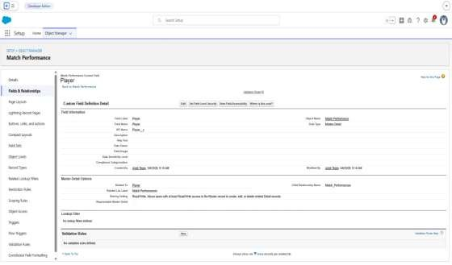

Milestone 6 : Roll-up Summary
Activity 1 : Create Roll-up Summary for Player object.

- Data Type : Roll-up Summary Field Label: Number of 50’s
Field Name : Auto Populates
Summarized Object : Match Performances
Select Roll-up Type : COUNT
Filter Criteria : Only records meeting certain criteria should be included in the calculation.
Click on Next → Next → Save and new.

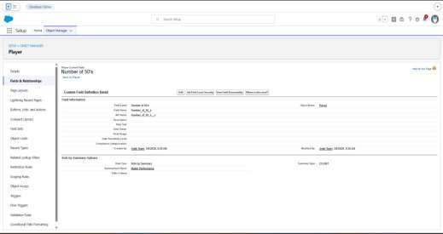

- Data Type : Roll-up Summary
Field Label: Number of 100’s
Field Name : Auto Populates
Summarized Object : Match Performances Select Roll-up Type : COUNT
Filter Criteria : Only records meeting certain criteria should be included in the calculation.
Click on Next → Next → Save and new.

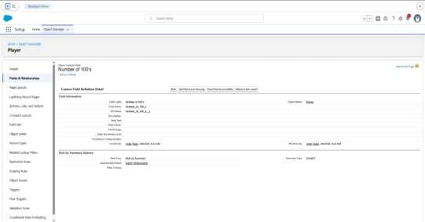

Milestone 7 : Flows

Activity 1 : Screen Flow
- Go to setup, Type Flow in quick find box → Click on the Flow and Select the
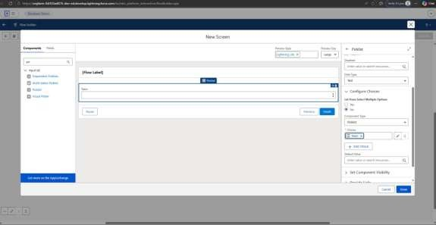
- Flow Label : Player Flow Flow API Name : Player_Flow

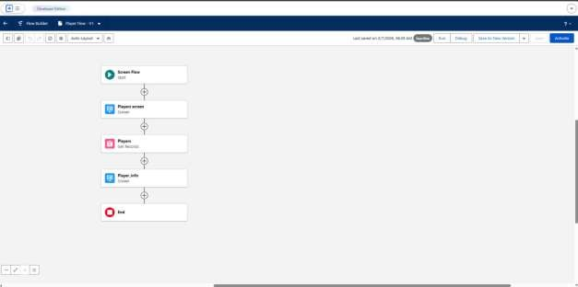

FUNCTIONAL & PERFORMANCE TESTING
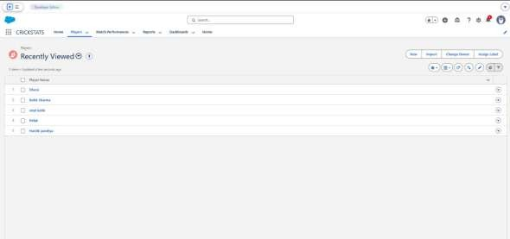

Conclusion
CRICKSTATS successfully implements a cloud-based cricket performance tracking system using Salesforce. The system automates data management, improves reportingaccuracy, and supports informed decisionmaking.
The project demonstrates practical application of SDLC, Agile methodology, and
CRM-based development.

